Dear Beavers, Cubs, Scouts, Parents/Guardians and Family!

We hope you are keeping well during this time of big changes in the way we have to live. We are all stuck at home, but that doesn’t mean we cannot continue our Scouting. With this in mind….

5th Frome are holding a Virtual Camp!

The details are below, we hope you will be able to join us!

When: Sunday 12th April, 15:00 to Monday 13th April 13:00
Where: Your home!
Cost: FREE
Register: https://us02web.zoom.us/meeting/register/u5EvduGqqz8inU0cXOcK0lvb7-ZOffMsEA
Programme:

Sunday 12th April
Time | Name | Where | Involves
15:00-16:00 | Opening Ceremony (In Uniforms) | Zoom Virtual meeting online | - Short tech intro  - Raise flag  - Intro to camp  - Explain Activities
16:00 – 19:00 | At home activities | Own homes, Offline | - Build Campsite/Tent  - Build Campfire  - Challenges  - Optional additional activities
19:00-21:00 | Evening Zoom (In Uniforms) | Zoom Virtual meeting online | - Review of day  - Wide game  - Campfire  - Drop Flag
21:00 | Camp out/in | Own homes, Offline | - Sleep in our tents

Monday 13th April
Time | Name | Where | Involves
09:00-10:00 | Morning Flag Break & eat breakfast together (In Uniforms) | Zoom Virtual meeting online | - Raise flag  - Breakfast together  - Explain Activities
10:00 – 13:00 | At home activities | Own homes, Offline | - Thank you, poster. Get a photo of the picture in the window with  - Virtual day out and review  - Challenges  - Optional additional activities
13:00-14:00 | Closing Ceremony (In Uniforms) | Zoom Virtual meeting online | - Review of days  - Awards Ceremony  - Drop Flag, Dismiss Camp

Our virtual camp will consist of online and offline activities we can all do from our home.

Zoom Virtual meetings online:
- We have 4 planned virtual meetings to bring everyone together.
- We’ll be using the software Zoom Cloud Meeting - Instructions and explanations are included further in this document
- We’d like uniforms to be worn.
- See Zoom instructions on page 3.

Tasks:
- Completed outside the virtual meetings
- 3 tasks for you to do Sunday afternoon,
- 2 tasks for Monday morning,

Challenges
- Completed outside the virtual meetings
- To be completed anytime throughout the camp
- Challenges to be revealed on camp.

Optional extra activities
- Completed outside the virtual meetings
- Pick any and have a go at whenever you fancy over the weekend.

We have included, on page 4 of this document, the current list of Tasks, Challenges and Optional Additional Activities to allow you to make any preparations if you so choose to, but we have tried to make all activities accessible to everyone.

We want to make this as interactive as possible so, as well as the Zoom virtual meeting events, we would like to interact through our Facebook page. If you don’t already follow us please find and like our page and join our Facebook event.

As you participate in the Tasks, Challenges and Activities, please photograph, video, save your documents and upload them to our Facebook page or you can email them to hello@5thFromeScouts.org.uk and we will upload them.

This virtual camp is open to the whole family to help us have fun as we ride out the country lockdown! #

Important:
- Although we have tried to decide on activities which are safe, we obviously we are unable to supervise and so need parents/guardians to take responsibility for the safety of those taking part of this camp.
- Please register at https://us02web.zoom.us/meeting/register/u5EvduGqqz8inU0cXOcK0lvb7-ZOffMsEA once you do, and have been approved, you’ll receive the joining details for the meeting.
- Please were uniforms to the Zoom meetings.

Any questions please get in contact.

Yours in Scouting,

The 5th Frome Leadership team.

Zoom instructions

We will be running some live sessions throughout the camp. These will be run via Zoom Cloud Meetings.

To join the online Zoom meeting:
- Zoom can be accessed on:
  - your phone/tablet - Download the app "ZOOM Cloud Meetings"
  - your PC:
  - Via Zoom programme: (recommended over using chrome) https://us04web.zoom.us/download#client_4meeting and download "Zoom Client for Meetings"
  - Via Chrome Web browser go to: https://zoom.us/join
NB: You don't need to set up your own Zoom user account, but you do need to register to join the meeting.

Please use the below link to register:

https://us02web.zoom.us/meeting/register/u5EvduGqqz8inU0cXOcK0lvb7-ZOffMsEA

You will be asked for your name, email address and “Please tell us who of your family is a member of 5th Frome, and which section they belong too.”

Once your registration is approved, you’ll receive an email with the meeting details on how to join.

Any queries or questions please get in contact via
- Facebook: https://www.facebook.com/5thFromeScouts/
- Email: hello@5thFromeScouts.org.uk
- Call Paul Marsh on 07834536757.

5th Frome Virtual Camp – Tasks, Challenges and Optional Additional Activities
As with all our camps, this virtual camp is jam-packed with things to do!
We have 3 tasks for you to do Sunday afternoon, 2 tasks for Monday, challenges to be completed anytime throughout the camp and a whole bunch of optional additional activities to pick from and have a go at whenever you fancy over the weekend.
With all the tasks and activities, we really want to see what you achieved, so please share your pictures, files and videos of you completing the below with us during the camp. You can either
- Upload to Facebook: https://www.facebook.com/5thFromeScouts/
- Email it to: hello@5thFromeScouts.org.uk

Please be safe while doing these activities and check what you’re doing with an adult.
Sunday Afternoon Tasks.
Build your campsite | You need somewhere to sleep! The most imaginative campsite will win. It could be a tent in your garden, or put the tent up in your living room, or build a tent in your living room.  We want to see pictures of you in your uniform in your campsite/tent! | Ideas:  - Pitch tent in garden  - Pitch tent in house  - Build a tent with bed sheets and sofa cushions house  - Build a tent outside
Build your campfire | What’s a camp without a campfire? – Your task is to build a campfire using whatever you can fine – it does not have to be real. The most imaginative campfire will win | Ideas:  - Real outdoor fire  - BBQ  - Gas cooker  - Candle  - Indoor fire place  - Build a Lego fire  - Draw a fire  - Paint a fire on cardboard
Covid-19 time Capsule | We are living through history right now.  Fill out this Covid-19 Time capsule to document this time. Share with us and keep it safe to re-read in the future.  You can download the pdf version, print it off and fill it out, or,  Download the page images to your computer/tablet/phone and fill it in on there. | Download:  - PDF Doc  - Images of Pages:  - Page 1  - Page 2  - Page 3  - Page 4  - Page 5  - Page 6  - Page 7  - Page 8  - Page 9  - Page 10  - Page 11

Monday Morning – pre morning flag break
Breakfast together | The aim to eat breakfast together as a group at the morning Flag break.  There is an award for “Most exciting Camp breakfast” so photograph/film how your cook and what your cook! | - You could cook your breakfast on the fire, camping stove, kitchen stove, BBQ.  - you could make your own utensils to eat with  - eat your cereal out of the box  - Create a pancake in a fun design  -Plate up your breakfast in a fun design

Monday Morning Tasks
Thank you Key workers! | There is a whole army of keyworkers who still go out to work every day  Doctors  Nurses  Police  Paramedics  Shop Workers  Teachers  Carers  Its important we let them know how grateful we all are they carry on working for us.  Download these “Thank you from the Scouts poster”, Decorated and colour in the poster, if you can print it off and stick it in your window, or post it to the 5th Frome Scout Facebook page so the key workers can see it.  You can download the pdf version, print it off and colour it in, or,  Download load the image to your computer/tablet/phone and colour it in on there. | Links:  Thank you from the Scouts:  - PDF Doc  - Jpg Image  Additional thank you posters:  NHS Rainbow  - PDF Doc  - Jpg Image  NHS Heart  - PDF Doc  - Jpg Image  Thank You Key Workers  - PDF Doc  - Jpg Image  Can you find any other posters online to download?
Virtual Day trip | Take a virtual day out and visit one or more of these attractions.  For each of these attractions you visit, take a photo of you enjoying the attraction and sum up your experience by answering the following questions:  1, Where did you visit?  2, Describe your tour.  3, List 3 things you saw on your tour.  4, List 3 interesting facts about your tour.  5, List 3 things you learnt on your tour.  6, What was your favourite thing on your tour? | Virtual Trips:  - Use Google Map Street View to explore a different town  - Longleat Safari Park  - National Aquarium  - San Diego Zoo  - Houston Zoo  - Walt Disney World  - Frozen Ever after Ride  - It’s a Small World  - Monsters Inc. Mike and Sulley  - Pirates of the Caribbean  - SeaWorld Orlando  - National Marine Aquarium  - LegoLand Florida  - Atlanta Zoo Panada Cam  - Monterey Bay Aquarium  - The Louvre  - Smithsonian National Museum of Natural History  - British Museum, London  - NASA  - Langley Research Center  - Glenn Research Center  Or you can try some "augmented reality experiences" via The Space Center Houston's app.

Challenges – to be done anytime over the camp
To be revealed on camp!

Optional Additional Activities – to do anytime over the camp
Activity | Descript | Resources/Notes/Tips
Bottled up emotions | Our current situation can lead us to experience a range of emotions. Let’s get these out of our head. Using the template, | Templates:  - JPG Image  - PDF doc  Example:  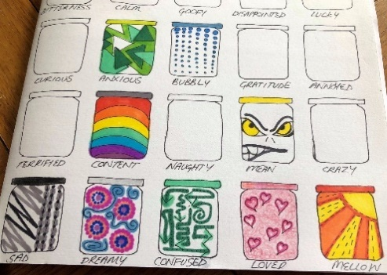
Matchstick Rockets | Create a Matchstick rocket  NB: to be done with an adult | Video Instructions
Send A hug | An easy way for us to brighten the day a friend or love one.  Draw around yourself, colour it in and write a message to someone you’re are not able to see at the moment | 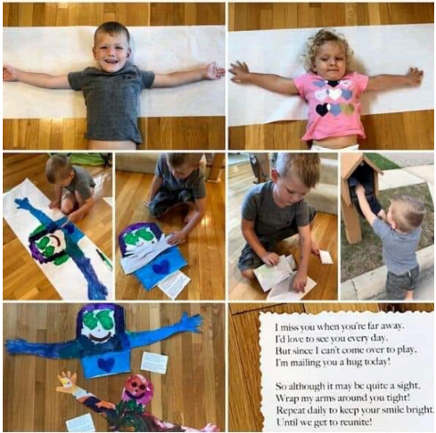
Learn magic trick | Learn a simple magic trick(s) and perform it/them for your family | - Search “Simple Magic tricks” on google
Learn to juggle | Spend some time learning a new skill! | - Look up juggling tutorials on YouTube  - You don’t have to start will balls, try juggling with handkerchiefs
Design your own stay at home badge | Using the template. Design your own stay at home badge.  - What would the badge look like?  - What tasks do you need to complete to gain the badge? | Link to template:  - PDF doc  - Word doc  - Jpg Image
Recreate a famous picture or scene. | Use your imagination to recreate a famous picture or scene. | Examples:  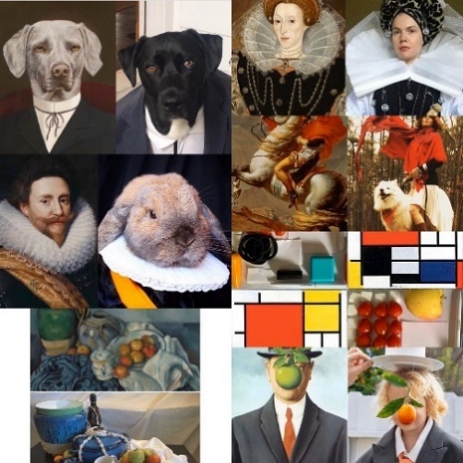
Knot | How are your Scouting Knots?  Learn or practice your knot skills, you can find the common knots in the linked factsheet. | - Scout Knots Factsheet  - Google the name of the knots, you might find videos to help you learn!
Origami Zoo | Create an origami zoo at home! | Suggested links:  - origamiway.com/origami-animals  - origami-instructions.com/origami-animals-instructions  - Search Google  - Find instruction videos on YouTube
Stop motion video | Using the free “Stop Motion Studio” create a short stop motion video on a theme of your choice. | Available on in the Apple and google app stores  You can find a tutorial video here: https://youtu.be/X_M468S86HI
Quiz | Complete the quiz. Message us on Facebook or hello@5thFromeScouts.org.uk with your answers to see how you did! | Beavers & Cubs Quiz  Scouts Quiz
Find an Activity badge to start working towards | Select an Activity badge and complete the required tasks.  Remember keep a record of what you did to fulfil the requirements. Providing these to your leader will mean you’ll be awarded the badge! | Beavers  Cubs  Scouts  Note: when you follow the link you’ll need to change the “Badge Type” drop down box from “Core Badges” to “Activity Badges”
Create a model Flagpole | Using whatever materials, you can construct a flagpole at home. | Material Ideas:  - Wood  - String  - Match sticks  - lollypop sticks  - Lego  - spaghetti  - Marshmallows  Design ideas  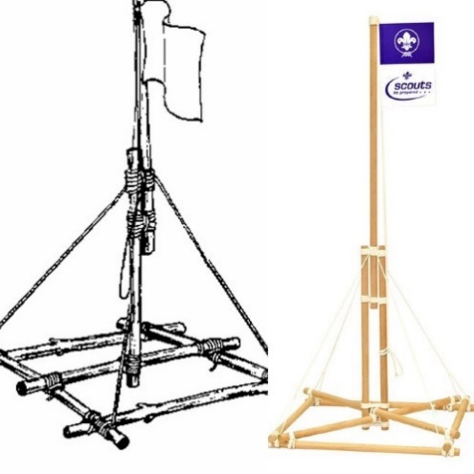  Or use your imagination!

